1.6: 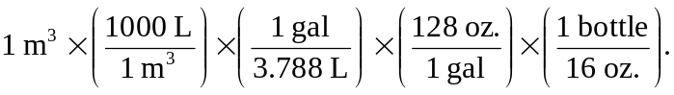
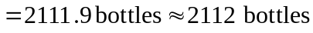

The daily consumption must then be
